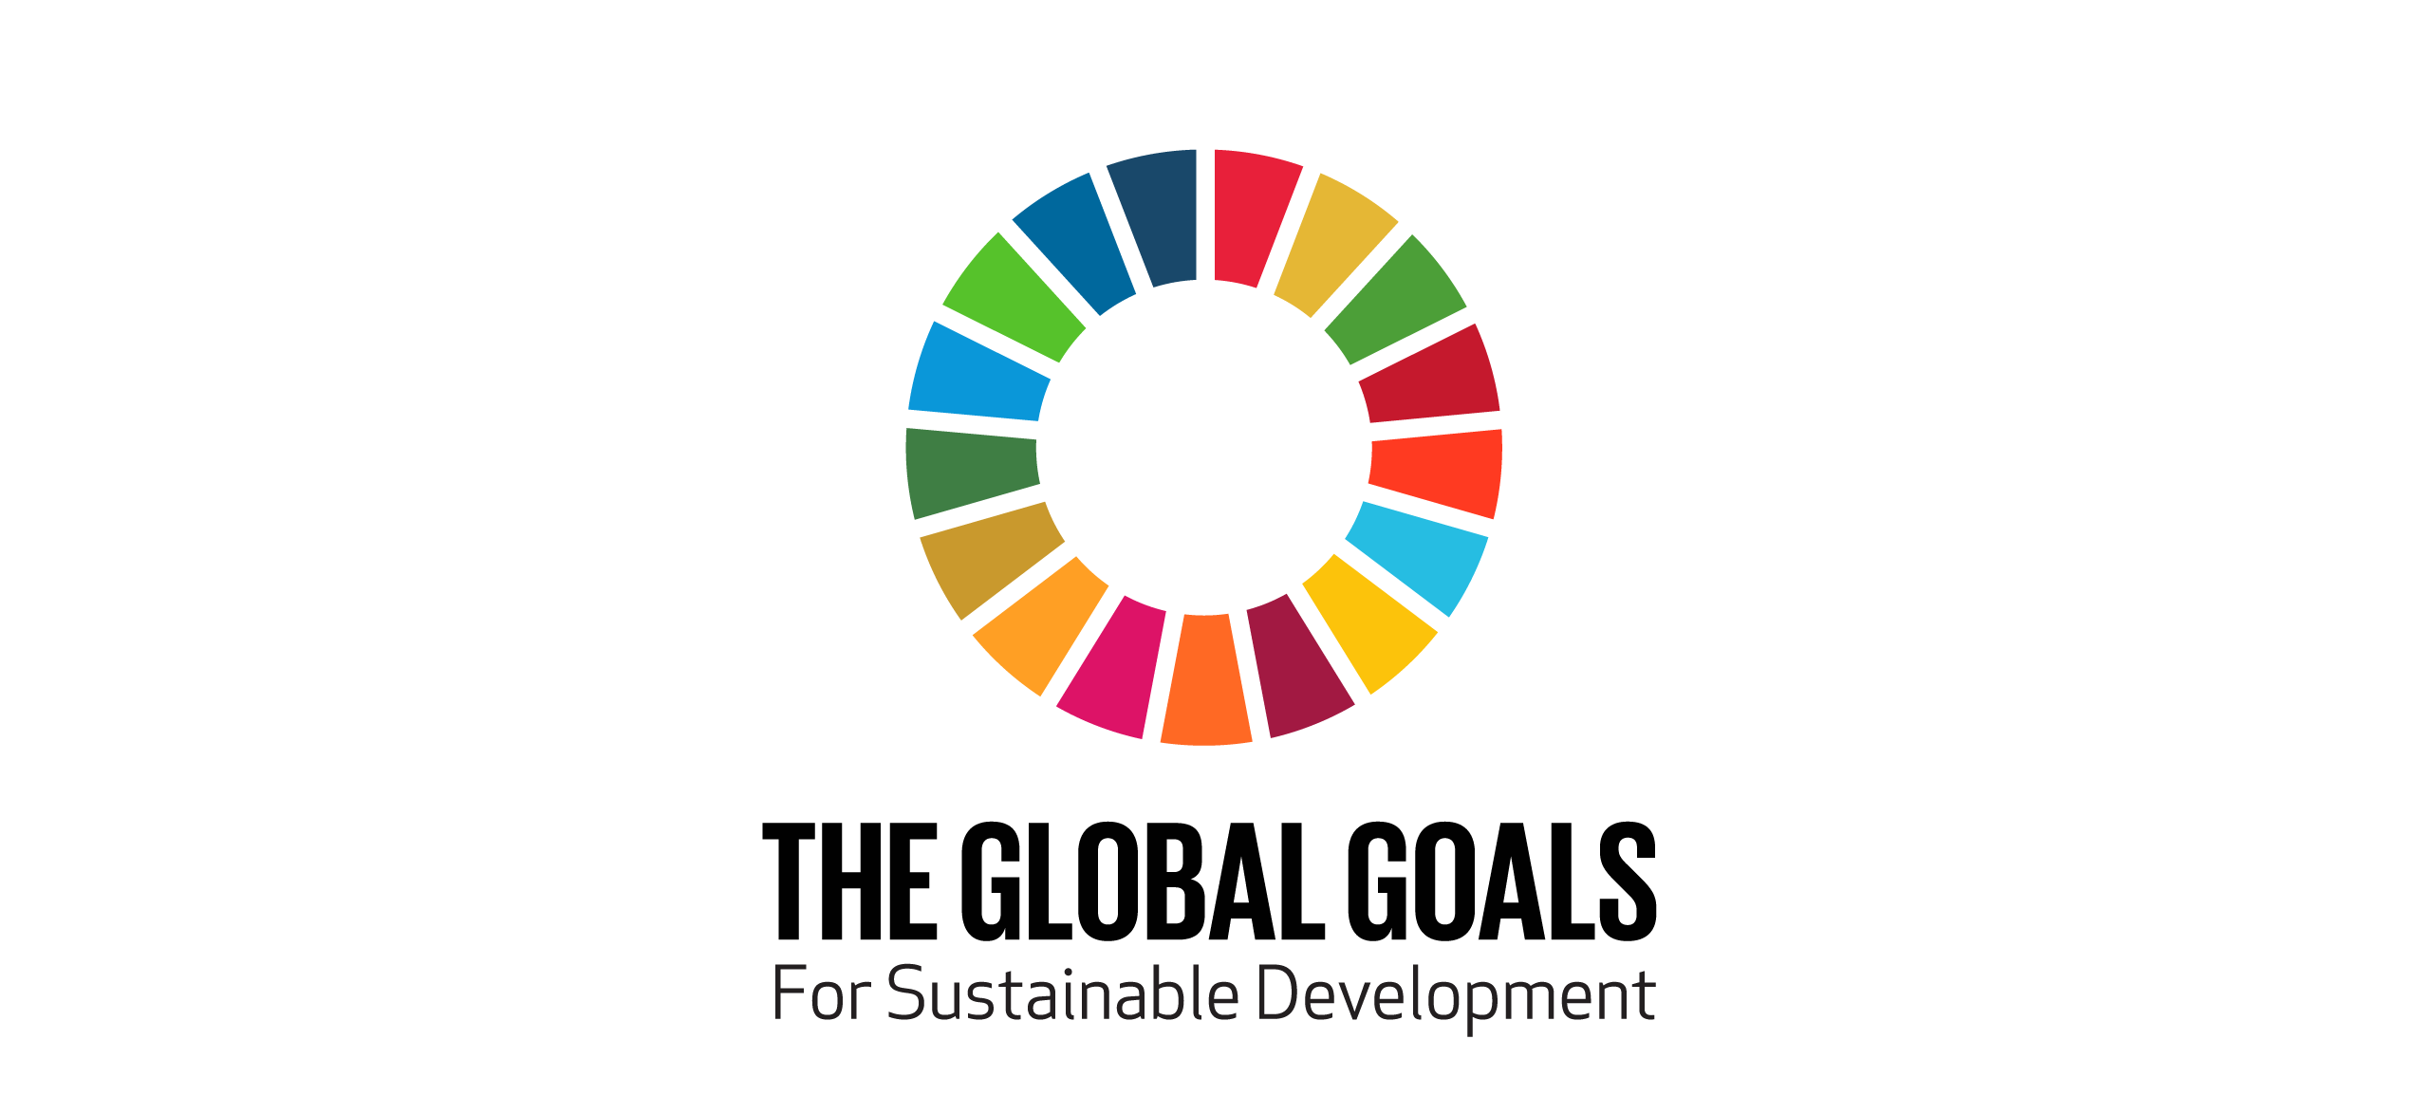
EMBARGO 00.01 GMT 9th September

A short film featuring Liverpool Football Club and Mekfah, a boy from Bangkok’s inner city slums is released today to mark the UN Global Goals campaign

9th September 2015

The film, directed by Ananda Everingham, the well-known Thai actor, tells the moving story of Mekfah. Living in the inner-city slums of Bangkok, Mekfah is a grade A student with a passion for football who gets to travel to Kuala Lumpur and interact with Liverpool Football Club, in conjunction with one of the Global Goals founding partners and Liverpool FC main sponsor, Standard Chartered.

The film is part of the Global Goals campaign launched last week at the UN Headquarters in New York by filmmaker Richard Curtis and Amina Mohammed, the Secretary-General’s Special Adviser on Post-2015 Development Planning The campaign aims to reach 7 billion people in the 7 days after the Global Goals are officially adopted by all 193 nations at the UN General Assembly on 25th September.

The themes explored in the film demonstrate how important the aims of the Global Goals are to the people on the ground most affected by them. If delivered the Global Goals will eradicate poverty, tackle inequality and fix climate change and this film takes on Goal 1, Zero Poverty and that whatever your dreams may be, poverty should not be an obstacle. The film also shows the important role that football plays as a beacon of hope to many communities around the world.

The voice over is by Mekfah himself, in Thai, with English subtitles.

Jordan Henderson, Liverpool FC said, “Mekfah is a great kid and his passion is clearly football. As we stood waiting to go on to the pitch in Kuala Lumpur I could tell how excited he was to be there.

“It was an honour to share that experience with Mekfah and with the help of the Global Goals, more kids around the world will be able to pursue their passion.”

Actor and Director, Ananda Everingham said, “I feel very passionately about this film. Meeting Mekfah took me on an unexpected journey and has probably changed my outlook on life. These Global Goals are important because they represent a plan. A plan that, if met by all world leaders, will ensure everyone - whoever they are and wherever they're from - can lead better lives unhindered by the shackles of poverty.”

Sanjeeb Chaudhuri, Group Head of Brand and Chief Marketing Officer at Standard Chartered, said, “We are extremely proud to be a founding partner of Project Everyone in support of the Global Goals campaign, and it was wonderful for us to have played a role in this powerful film.”

ENDS
To view the full film, please visit the Global Goals Youtube channel: http://youtu.be/Q07laokNXeU

For a shorter teaser film, please visit: http://youtu.be/oByfVAoolnA
To access this and the image of Jordan Henderson, Liverpool FC captain with Mekfah as mascot, go to our media centre: http://www.globalgoals.org/media-centre/

For further information, interview requests with Ananda Everingham or broadcast quality versions of the film, contact: jess@project-everyone.org +65 94486392

ABOUT GLOBAL GOALS CAMPAIGN

On 25th September at the UN, 193 world leaders will adopt the Global Goals, a series of 17 ambitious goals to end poverty, fight inequality & injustice and tackle climate change for everyone by 2030. The Global Goals campaign aims to both make the goals famous and to push for their full implementation. If the goals are famous - if people care about what has been promised by the politicians - it greatly increases their chance of being implemented.

Speaking about the ground-breaking collaboration Richard Curtis, founder of Project Everyone, said “The Millennium Development Goals halved extreme poverty across the world. The new Global Goals for Sustainable Development give us the opportunity to end it for good. There’s no point in going half way. By making the Global Goals famous we can give them their best chance of working around the world - and help make us the first generation to end extreme poverty, the most determined generation in history to end injustice and inequality, and the last generation to be threatened by climate change.”

Liverpool FC and Standard Chartered have not only helped with this film but players completed their own dizzy goals challenge, contributed to Radio Everyone, the World’s Largest Lesson and We the People.

Their activity will culminate at the fixture against Aston Villa on Saturday 26th September 2015, where Liverpool FC will replace the Standard Chartered logo on their shirts with the Global Goals logo.

ABOUT PROJECT EVERYONE
Project Everyone is the brainchild of Richard Curtis with the ambition to tell everyone in the world about the Global Goals so they are best achieved. The project’s Founding Partners include Aviva, Getty Images, Pearson, SAWA Global Cinema Advertising Association, Standard Chartered, Unilever and the Bill and Melinda Gates Foundation.

All over the world the project is being supported by hundreds of television, radio , poster and digital companies, mobile phone and broadband providers, NGO organisations from all sectors, businesses, sports clubs, film and television production companies, record labels, events, magazines and retailers, all of whom have agreed to carry the goals to their fans, customers and users to help them become known all over the world.
www.globalgoals.org
www.projecteveryone.org

ABOUT THE GLOBAL GOALS FOR SUSTAINABLE DEVELOPMENT
The Sustainable Development Goals are at the heart of the ambitious new global agenda that have been agreed and will be adopted by the 193 Member States at the Sustainable Development Summit which will take place September 25th-27th, 2015, in New York at the United Nations. More than 160 world leaders will be in New York to adopt the goals -- which builds on the UN's successful Millennium Development Goals (2000-2015) that have lifted millions out of poverty. This new agenda will build on the successes and go further because it is a universal agenda that will improve the lives of all people around the world.

Through an integrated approach, the goals will tackle the social, economic and environmental challenges to achieve sustainable development to meet the needs of the present without compromising the ability of future generations to meet their own needs. The new Sustainable Development agenda will guide all countries on a path that will transform the lives of all people toward increased prosperity and greater well-being while protecting the environment.

