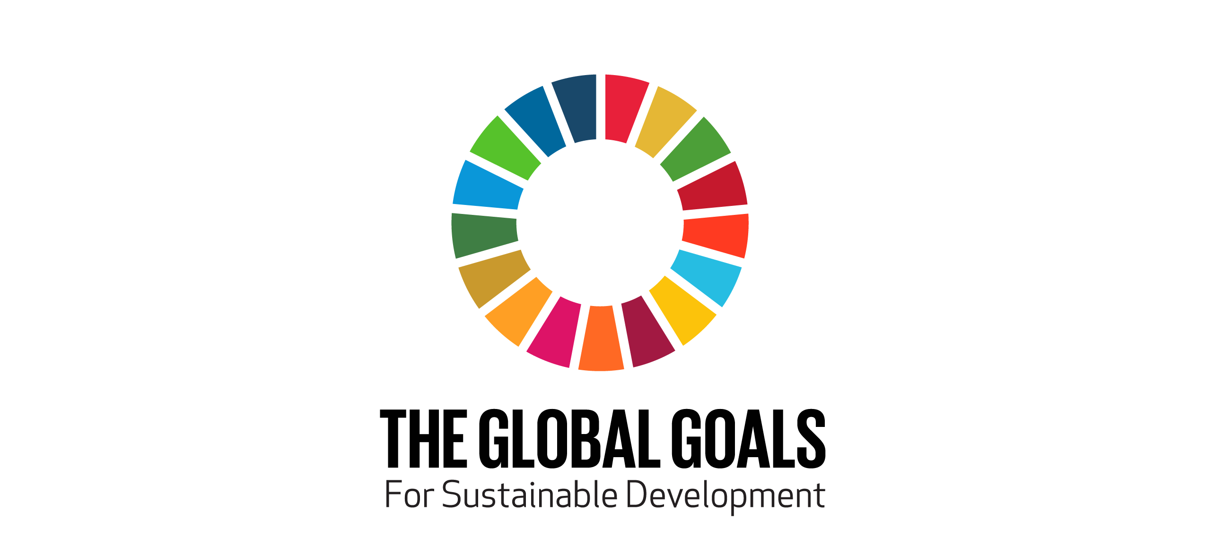

‘WE THE PEOPLE’ – Add Your Voice!
http://wethepeople.globalgoals.org
“By uniting faces and voices from all over the world, we will create a film with the biggest cast ever. We’ll show it to the world when the UN Global Goals launch on 25th September to pledge our support for a brighter future.”

Today, the Global Goals Campaign launches “We the People” - a crowdsourced film where everyone is invited to join the world’s biggest cast and star alongside A R Rahman, Ashton Kutcher, Bill and Melinda Gates, Cate Blanchett, Daniel Craig, G.E.M, Gilberto Gil, Jennifer Lawrence, Jennifer Lopez, Kate Winslet, UN Messenger of Peace Lang Lang, Meryl Streep, Malala Yousafzai, One Direction, Her Majesty Queen Rania Al Abdullah of Jordan, Richard Branson, Robert Pattinson, Robert Redford, Stephen Hawking, UN Messenger of Peace Stevie Wonder and UNDP Goodwill Ambassador for China Zhou Xun among others. The film will be unveiled on the Google homepage when the Goals are adopted on the 25th September.

Other artists and activists who have already contributed and crowdsourced footage include: Akshay Kumar, Alice Braga, Ananda Everingham, Anastacia, Avan Jogia, Becca, Chelsea Islan, Christina Hendricks, Criolo, Diamond, Diego Luna, Hrithik Roshan, James Chau, Jamie Oliver, Liverpool Football Club captain Jordan Henderson and team mates, Lenine, Mia Maestro, Mafikizolo, Mads Mikkelsen, Mena Suvari, UNDP Champion Michelle Yeoh, Nazanin Boniadi, Paul Wesley, Phoebe Tonkin, Rodrigo Santoro, Saoirse Ronan, Sun Yang, UNICEF supporter Tom Hiddleston, Thanh Bui, Wagner Moura and Yemi Alade.

Help us to ‘Tell Everyone’ about the Global Goals by adding your voice to the film - written and directed by filmmaker Richard Curtis (Notting Hill, Four Weddings and Funeral, Love Actually) and Mat Whitecross (Spike Island, Sex&Drugs&RocknRoll, Road to Guantanamo) and created by The Rumpus Room – this is your chance to co-star alongside some of the world’s most famous people!

How To Take Part
We the People is launching with a tutorial video written by players from Get Lit, an education programme that engages urban youth in classic and spoken word poetry in Los Angeles, in a unique collaboration with Richard Curtis.

From 3rd September, you can submit your contribution at http://wethepeople.globalgoals.org and share footage of yourselves reading lines from the script written by Richard Curtis, outlining the ambition and themes of the goals. Choose the goal you feel most passionate about – whether that’s women’s rights like Jennifer Lawrence or life under water like Meryl Streep. Film yourself reading the lines. And upload your footage.

The Outcome
Entries will be edited together into a final crowd-sourced video using footage submitted by people all over the world. The video will feature as many different faces and voices as possible, and will be screened at the Global Citizen festival in New York on 26th September and included in a 1-hour special TV programme to be broadcast globally in over 20 countries.

ABOUT THE GLOBAL GOALS CAMPAIGN
On September 25th 2015, at the United Nations Headquarters in New York, 193 world leaders will commit to 17 Global Goals to achieve three extraordinary things in the next 15 years. End extreme poverty, fight inequality and injustice, fix climate change. If the goals are famous, they won’t be forgotten. Everyone needs to know about the Global Goals for Sustainable Development and so the Global Goals campaign - with Global Citizen, action/2015, and UN agency partners - aims to reach 7 billion people in 7 days. Founded by Richard Curtis in partnership with the UN, the Global Goals campaign is the biggest-ever collaboration of NGOs, global brands, public figures, educators, sports clubs, faith leaders, TV and radio broadcasters, cinema advertisers, telecoms operators, digital and social media platforms, creative and media agencies, publishers, space organisations, artists and grassroots organisations.

ABOUT GET LIT
Get Lit – Words Ignite builds scholars, not statistics, by engaging urban youth in classic and spoken word poetry, in Los Angeles and beyond. Their poets have travelled to the Hollywood Bowl, the Library of Congress, and even the White House, as ambassadors for art and social consciousness. Join the #LiteraryRiot at www.getlit.org

SCRIPT

We can be – we must be - the first generation to end extreme poverty.
The generation most determined to fight injustice and inequalities.
And the generation that saves the planet from climate change.
And this is how it will get done. The Global Goals – a 15 year plan for everyone, everywhere – with no one left behind.
- We will live in a world where nobody anywhere lives in extreme poverty.

- We will live in a world where no-one goes hungry, no one wakes in the
morning, asking if there will be food today.

- We will live in world where no child has to die from diseases we know how to cure and where proper healthcare is a lifelong right for us all.

- We will live in a world where everyone goes to school - and education gives us the knowledge and skills for a fulfilling life.

- We will live in a world where all women and all girls have equal opportunities to thrive and be powerful and safe. We can’t succeed if half the world is held back.

- We will live in a world where all people can get clean water and proper toilets at home, at school, at work.

- We will live in a world where there’s sustainable energy for everyone – heat, light and power for the planet without destroying the planet.

- We will live in a world where economies prosper and new wealth leads to decent jobs for everyone

- And we will live in a world where our industries, our infrastructure and our best innovations are not just used to make money – but to make all our lives better.

- We will live in a world where prejudices and extremes of inequality are defeated - inside our countries and between different countries.

- We will live in a world where people live in cities and communities that are safe, progressive, and support everyone who lives in them.

- We will live in a world where we replace what we consume – a planet where we put back what we take out of the Earth.

- We will live in a world that is decisively rolling back the threat of climate change.

- We will live in a world where we restore and protect the life in our oceans and seas.

- We will live in a world where we restore and protect life on land - the forests, the animals, the earth itself.

- We will live in a world with peace between and inside countries, where all governments are open and answer to us for what they do at home and abroad - and justice rules, with everyone equal before the law.

- And we must live in a world where all countries and we, their people, work together in partnerships of all kinds, to make these Global Goals a reality for everyone, everywhere.

These are the United Nations Global Goals for Sustainable Development. Agreed on by our 193 countries.
This is the plan. Let’s get to work. Let’s make it happen.

